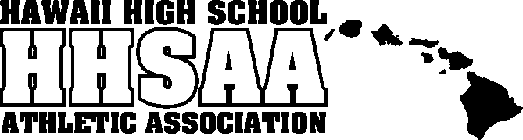
Hawaii High School Athletic Association
----------------------------------------------------------------------------------
 P.O. BOX 62029  HONOLULU, HAWAII 96839 
PHONE: (808) 800-4092
 www.sportshigh.com - info@hhsaa.org 

2017 NEW CITY NISSAN / HHSAA BOYS VOLLEYBALL
SOUVENIR T-SHIRT & TOURNAMENT PROGRAM PRE-ORDER FORM

School requests to order the following sizes of the souvenir T-shirts at $20.00 per shirt and Souvenir Tournament Programs at $7.00.

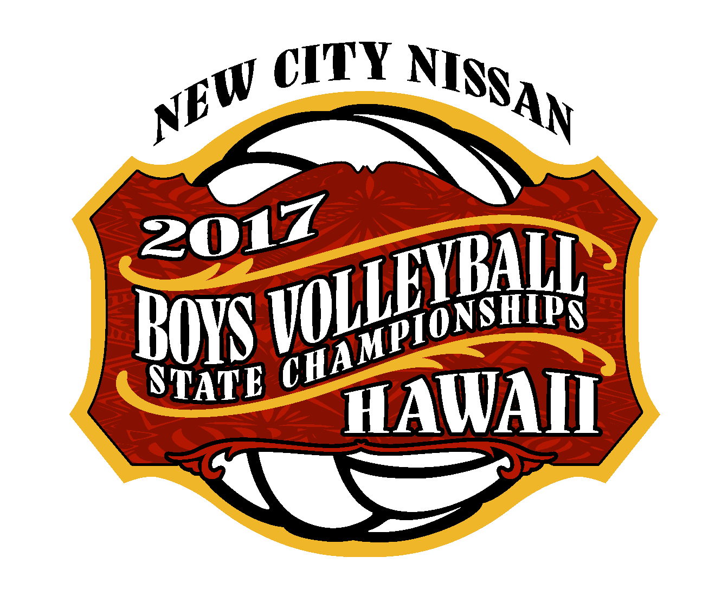
Size | Quantity | Price | Total
Small |  | $20.00
Medium |  | $20.00
Large |  | $20.00
X-Large |  | $20.00
XX-Large |  | $20.00
Program |  | $7.00
 |  | GRAND TOTAL

E-mail preorders to the HHSAA office at the contact information listed below. Checks payable to HHSAA may be brought to the site of team’s first game. Preorders must be paid in full by first day of the tournament or shirts will be released to the public for sale.

Contact person:

Daytime phone:

E-mail:

DIVISION I & II:
Russell Aoki
HHSAA
E-mail: aoki@hhsaa.org

