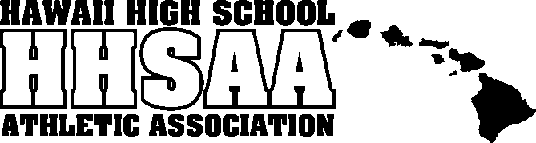
Hawaii High School Athletic Association
----------------------------------------------------------------------------------
 P.O. BOX 62029  HONOLULU, HAWAII 96839 
PHONE: (808) 587-4495  FAX: (808) 587-4496
 www.sportshigh.com - info@hhsaa.org 

CARLSMITH BALL TENNIS STATE CHAMPIONSHIPS
THURSDAY-SATURDAY, MAY 7-9, 2015
Patsy T. Mink Central Oahu Regional Park

GIRLS ENTRY FORM
INSTRUCTIONS:
E-mail completed entry form to roster@hhsaa.org by Monday, April 27, 2015, noon. Faxed or other hard copies will not be permitted.

SCHOOL |  | LEAGUE

 | GIRLS SINGLES | Grade | Date of Birth | Date of 1st Entry into 9th Grade
1
2
3
4
5
 | GIRLS DOUBLES | Grade | Date of Birth | Date of 1st Entry into 9th Grade
1a
1b
2a
2b
3a
3b
4a
4b

HEAD COACH
E-mail |  | CELL PHONE

ASST. COACHES

E-mail form to: roster@hhsaa.org

