
Hawaii High School Athletic Association
----------------------------------------------------------------------------------
 P.O. BOX 62029  HONOLULU, HAWAII 96839 
PHONE: (808) 587-4495  FAX: (808) 587-4496
 www.sportshigh.com - info@hhsaa.org 

2014 CARLSMITH BALL / HHSAA TENNIS TOURNAMENT
SOUVENIR T-SHIRT PRE-ORDER FORM

School requests to order the following sizes of the souvenir A4 Drifit T-shirts at $20.00 per shirt.

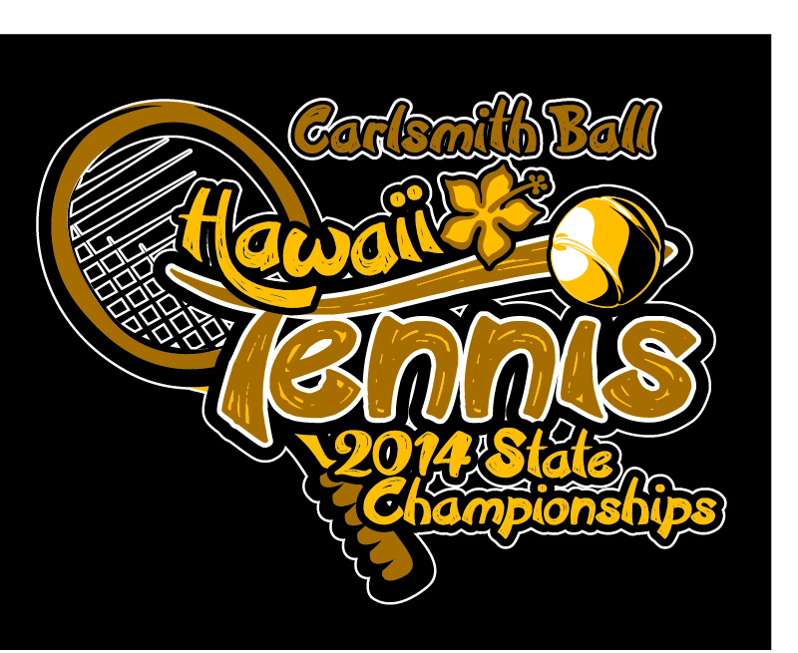
Size | Quantity | Price | Total
Small |  | $20.00
Medium |  | $20.00
Large |  | $20.00
X-Large |  | $20.00
XX-Large |  | $20.00
Tourney Program | N/A | N/A | N/A
 |  | GRAND TOTAL

Email preorders to your respective host (see below) school. Checks payable to HHSAA may be brought to the coaches’ meeting/ first day of the tournament. Note: preorders must be paid in full by first day of the tournament or shirts will be released to the general public.

HOST SCHOOL:
Keanen Reader, Athletic Director

Contact person: __________________

Daytime phone: __________________

Email Address: __________________

Maui Preparatoy Academy
Phone: (808) 665-9966
E-mail: kreader@mauiprep.org

