
Hawaii High School Athletic Association
----------------------------------------------------------------------------------
 P.O. BOX 62029  HONOLULU, HAWAII 96839 
PHONE: (808) 587-4495  FAX: (808) 587-4496
 www.sportshigh.com - info@hhsaa.org 

2015 DATAHOUSE / HHSAA SOFTBALL
SOUVENIR T-SHIRT & TOURNAMET PROGRAM PRE-ORDER FORM

School requests to order the following sizes of the souvenir A4 Drifit T-shirts at $20.00 per shirt and Souvenir Tournament Programs at $7.00.

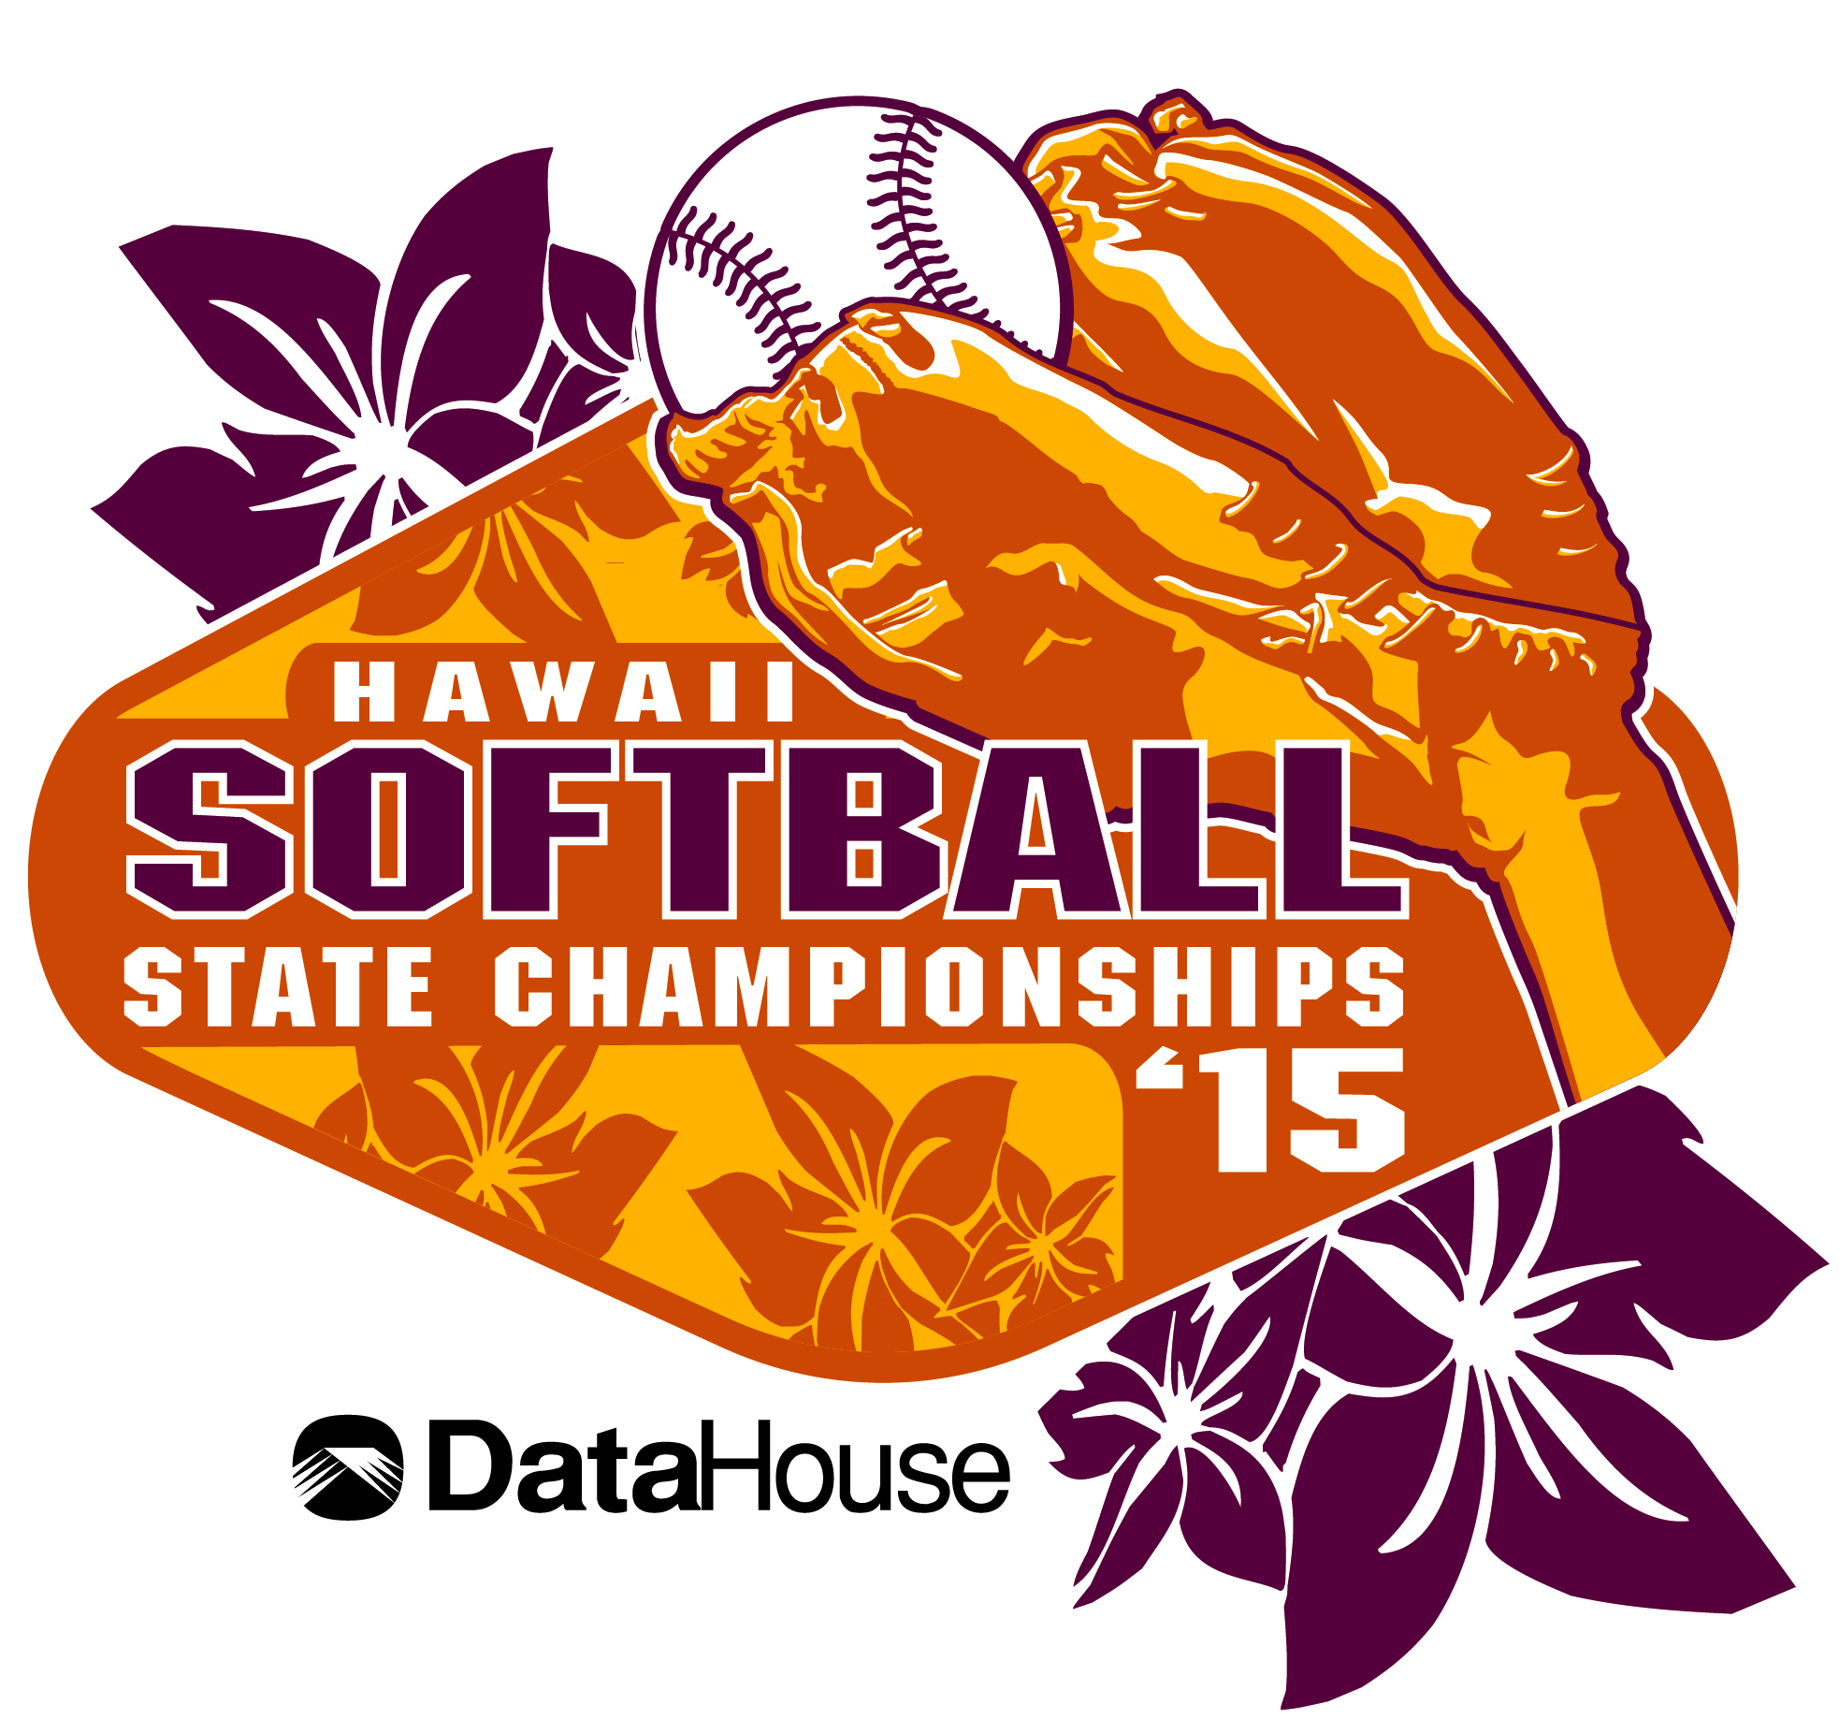
Size | Quantity | Price | Total
Small |  | $20.00
Medium |  | $20.00
Large |  | $20.00
X-Large |  | $20.00
XX-Large |  | $20.00
Tourney Program |  | $7.00
 |  | GRAND TOTAL*

Email preorders to your respective host (see below) school. Checks payable to HHSAA may be brought to the coaches’ meeting/ first day of the tournament. Note: preorders must be paid in full by first day of the tournament or shirts will be released to the general public.

DIVISION I:
Missy Kilbey, Athletic Director

Contact person: __________________

Daytime phone: __________________

Email Address: __________________

St Andrews Priory
Phone: (808) 532-2461
E-mail: mkilbey@priory.net

DIVISION II:
Bob Morikuni, Athletic Director
Mckinley High School
Phone: (808) 590-0413
E-mail: bob_morikuni@notes.k12.hi.us

*Note: Compliments of the softball tournaments’ title sponsor, DataHouse, each team shall be provided 12 free t-shirts for the participating athletes, which will be distributed at the pretournament coaches’ meeting. Please complete this form and send in to the host school by the deadline. Additional shirts above the allotted 12 complimentary shirts must be paid in full by first day of the tournament or shirts will be released to the general public.

